Static Testing

What is Static Testing
# Source: Chatgpt (GPT-5-Standard) at [8/14/2025]
Static Testing is a type of software testing where the software is examined without actually executing the code.
Instead of running the program, you review and analyze documents, code, and design to find defects early in the development lifecycle.

Key Points
# Source: Chatgpt (GPT-5-Standard) at [8/14/2025]
- Goal: Detect errors, inconsistencies, or deviations from requirements before running the software.
- When: Performed in the early phases of the Software Development Life Cycle (SDLC).
- How: Through reviews, walkthroughs, inspections, and static analysis tools.
- Cost Benefit: Defects found here are cheaper to fix than those found after execution.

Types of Static Testing
# Source: Chatgpt (GPT-5-Standard) at [8/14/2025]
- Manual Static Testing
  - Reviews (informal checking)
  - Walkthroughs (author explains content to peers)
  - Inspections (formal, checklist-based defect finding)
- Automated Static Testing
  - Static code analysis using tools (e.g., SonarQube, ESLint, PMD)
  - Automated scans for security vulnerabilities, code smells, or unused variables.

Examples
# Source: Chatgpt (GPT-5-Standard) at [8/14/2025]
- Reviewing requirements documents to check for ambiguity.
- Checking test cases for coverage and correctness before execution.
- Analyzing source code for:
  - Unused variables
  - Syntax violations
  - Potential security flaws (e.g., SQL injection risks)
- Verifying design documents against architecture standards.

Static vs. Dynamic Testing
# Source: Chatgpt (GPT-5-Standard) at [8/14/2025]
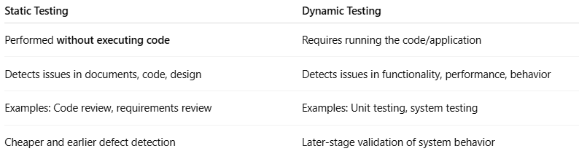
Static Testing | Dynamic Testing
Performed without executing code | Requires running the code/application
Detects issues in documents, code, design | Detects issues in functionality, performance, behavior
Examples: Code review, requirements review | Examples: Unit testing, system testing
Cheaper and earlier defect detection | Later-stage validation of system behavior

💡 In short: Static testing is like proofreading a book before it’s printed, while dynamic testing is like reading the book aloud to see if the story works.

